CHANGE OF ADDRESS

If you have moved house recently, or are about to move, please fill in the address slip below and either hand it to your elder, or post it to Sheila Bertram, 42 Pentland View, Edinburgh EH10 6PS.

Thank you.

Name(s): ……………………………………………………………………………………

OLD address: ……………………………………………………………………………..
………………………………………………………………………..............................

NEW address: ……………………………………………………………………………
................……………………………………………………………………………………

NEW Phone Number: ……………………………………………………………….

Moving date: …………………………………………………………………………….

Tron Kirk Gilmerton and Moredun
Church of Scotland Edinburgh, Registered Charity SC009274
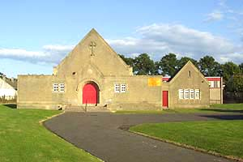 | 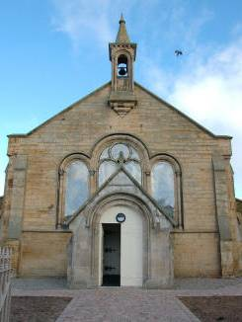

THE CHRONICLE
OCTOBER 2019

SUNDAY SERVICES

TRON KIRK MOREDUN 10.30am

TRON KIRK GILMERTON 5.00pm

MINISTER - REV CAMMY MACKENZIE

Magazine of the Tron Kirk Gilmerton and Moredun
LETTER FROM OUR MINISTER

Hi everyone and welcome to our final newsletter of the year at Tron Kirk.
I do hope your summer went well, though obviously I know it cannot have gone well for everyone. I really hope though that whether it has gone swimmingly or terribly that you know that the Lord has been with you as He has been with me.

As you read this I have just completed a two day training course over at Edinburgh zoo at which the subject was suicide prevention and it really was one of the most informative and challenging courses I have ever been involved with! It was VERY moving as we covered the variety of course material and heard personal anecdotes both from the two Lyndas' running it and from those of us among the 26 who were receiving this training. The fact is that I did find the course really inspiring because it gave me insights into research that has been done over the last 25 years or so and it gave me confidence to ask someone , who is showing signs of not being in a good place to simply come out and ask them "Are you considering killing yourself".

Now I realise that this may seem on first reading to be perhaps a stupid or hurtful thing to say but if I told you that a very high percentage of survivors of serious attempted suicide had said they" would not have tried it if they had had the chance to speak about it first:.....

You see they all testified that they had been so low and so lost that it seemed the only way out. The course then taught us how to spot the :Invitations" which are some signs that someone is presenting sometimes fairly obvious or more subtle signs they are far from well and then having asked them this straight out question how to move with them through their story to a place where they can agree to disarm any plans they might have in place and then agree a positive plan of how to stay safe and start to find help and support to address the underlying issues and find hope for the future. The key is to have someone brave and caring enough to offer help.

So here is my question to you and indeed a question that equips us all to help others and keep each other safe.....
Are you planning to kill yourself? If the answer is YES then please talk to someone, talk to family friends.
TALK TO ME CAMMY (07838912361)

In just a few weeks time it will be Christmas and that time of year is famous for being a bit of a roller coaster ride of emotions. For Moira who lost dear Bill just a few weeks ago and for Val who lost her mum last week this Christmas will be different from last Christmas and next Christmas indeed from ANY other Christmas time. The fact is that it is a time of year when the best and sometimes worst times are

had by all but please believe me when I say that Jesus came to give us hope in a sometimes dark world and to bless us with peace love and Joy. But what He offers us is not just a sticking plaster or a plastic happiness which like the tinsel and the little trinkets inside our Christmas crackers will end up tossed in the rubbish. He offers us HIMSELF and He is more than enough to help us get through any challenges we face.

I came across this reading in Spill the Beans which is part of the book of Revelation. It has been written from God through John to us. I want to finish with it today and invite you all to meditate upon it and put your own name into the text that you might understand that God is saying these things to you and to me.
God bless you now and always.....

Dear everyone....
I write you this letter because sometimes you simply need encouragement. Maybe we don’t encourage each other often enough. Perhaps we should spend some time each day saying what we love about each other instead of complaining.
So, my friends, here’s what I want to say: you are amazing people. You have talent and gift and laughter and friendship and so many ways in which you shine the light of the gospel. Continue to do so.
And I want to remind you that you are lights of the gospel because when people forget to encourage, and take you for granted, sometimes the light dims, you wonder if it is worth it. You might even find yourself giving up, turning your back on what is possible because it seems no one notices.
Well I notice. I notice how good you are at exploring and asking questions and taking risks for the Good News. I notice how you try out ideas and find way to be God’s People in new situations. I notice the conversations you have that attempt to make church interesting and relevant.
Keep going. Continue to listen for, and listen to, the spirit. He is the great encourages. He will disturb easy ways and provoke great thoughts but He is our strength and guide and our imagination.
Whenever something comes to do you down, remember this letter from me. I know what it is like. I know the gospel can be difficult. I know it can be lonely and sometimes you feel you are the only ones holding on.
But you aren’t. You are marvellous and wonderful people. You have what it takes. You add creativity and uniqueness to the message because of who you are. Please be yourself more and more. It is all you need to be and in turn encourages others in their times of difficulties. Thank you for being you.

Cammy

T A G

This group meets on a Thursday Afternoon from the beginning of September until June. We meet every second Thursday from 2.00pm until approximately 3.30pm. If you are free and are looking for something to do on a Thursday afternoon please come along and join us. It is mostly a fun afternoon and sometimes we do have a speaker. The cost is £1.00 and tea and biscuits are supplied.

If you would like any further information please speak to Alice Laing, Sheena Anderson or Pat Wilson.

******************************

HOME COMMUNION

You may be one of our more elderly on infirm members who are not now able to attend church and also miss out on Communion Sundays. If you would like to receive Communion in your own home please contact the minister Cammy Mackenzie on 664 7538 or our Session Clerk Sheila Bertram on 445 2129, who will be able to arrange this for you.

******************************

LIFE and WORK MAGAZINE

If you would like to receive a copy of the Church of Scotland Life and Work Magazine please speak to Sheena Anderson.

 |  | FLOWER LIST
NOVEMBER |  |  | JANUARY
03 | Doreen & Marjory |  | 05 | Jeanna Davidson
10 | Lillian Gray |  | 12 | Chic Watson
17 | Beth Ferrier |  | 19
24 | Lorraine Imrie |  | 26
DECEMBER |  |  | FEBRUARY
01 | Liz McDougall |  | 02 | Liz McDougall
08 | Jean Williams |  | 09 | Avie Linton
15 | Denise & Ivor Forrest |  | 16 | Denise & Ivor Forrest
22 |  |  | 23
29 | Jim & Kate Fisher

Anyone who would like to add their name to the flower calendar or can
help with the distribution of the flowers after the service please speak to
Pat Wilson Tel: No. 666 1078.

********************

YOUR HELP IS REQUIRED

The smooth running of the church depends on everyone contributing in some way. We have separate committees which are responsible for different aspects of the functions of the church.
These committees look after the social events, the financial side, the care of the property and pastoral care. They meet to discuss relevant matters and the convener reports back to the Session who take the final decision as they carry the responsibility. Your help to serve on one of these committees would be greatly appreciated, particularly the property committee.
If you would like more information or would be happy to serve on one of the committees please contact Sheila Bertram, Alice Laing or Cammy Mackenzie.
Thank You for giving this some consideration.

HELP US TO HELP YOU

The elders and minister of the Tron Kirk want to keep in touch with all our members and remember them in our prayers when they are in any difficulty, sick or in need of support. We want to know when someone is in hospital or ill at home and we are particularly anxious to keep in touch with our older and frail members who are unable to attend church. We need your help to do this. If a member of your family is ill please let their elder know, every member should have a card with the name and telephone number for their elder. If you cannot find the card then contact any of the named elders listed in the Chronicle which you receive four times a year or contact the Session Clerk, Sheila Bertram, whose address and phone number are on the back page of the Chronicle.

It is particularly important that a family member or friend lets us know when someone moves away to be closer to family or to receive nursing care. It can be distressing to ring a bell only to be told that the person is now in a nursing home but nobody knows which home. Our pastoral care team is trying hard to ensure that all members in nursing homes receive regular visits but we cannot do that if we are not told when they move and where they are now based. Please help if you can by keeping in touch with one of the elders, Ivor Forrest our Pastoral Assistant, or the Minister.

We also like to celebrate with our members and give thanks for good news and special events. If you are celebrating a special birthday, an anniversary or a new baby in the family please let Alice Laing know so that she can include your special occasion in the Chronicle and we can remember you and give thanks in our prayers.

Sheila Bertram
Session Clerk

******************************

CHRISTMAS FUNNIES

CHRISTMAS FAYRE

Our Christmas Fayre, which is our main fund raising event of the year, is on Saturday 23 November 11.00am until 1.00pm. The stalls will include Cake & Candy, Tombola, £1.00 Jar & Bottle Stall, a Raffle and our Christmas Craft & Gift Stall. There will also be hot filled rolls and tea and coffee. Please put the date in your diary and come along and support us on the day of the sale.

If you have anything you would like to contribute to any of these stalls please bring them along to the church any Sunday or on Friday afternoon 22nd November between 2.00-3.00pm when we will be setting up.

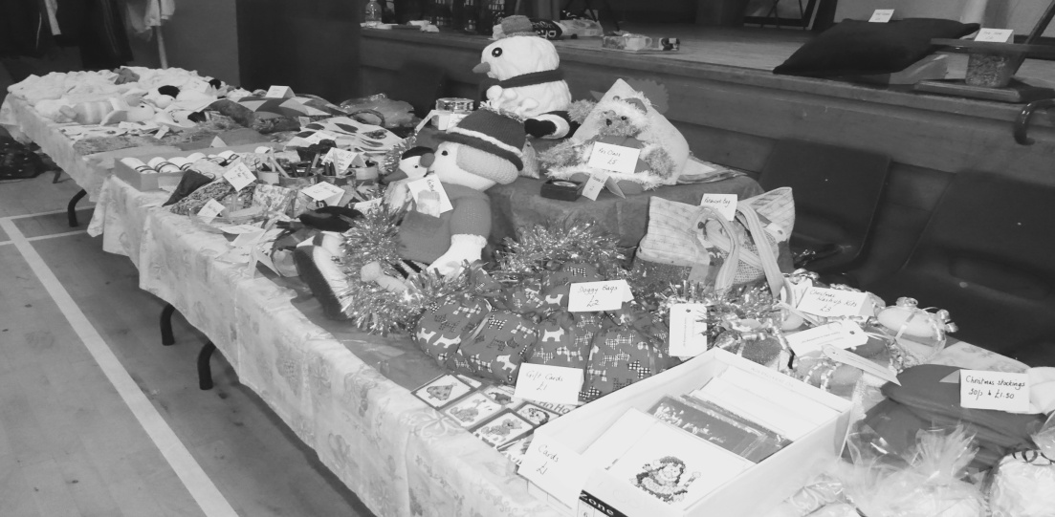

CAN YOU HELP WITH SUNDAY MORNING TEAS?

Thank you to those people who provided the teas following the service during July, August, September and October. Volunteers are required for the coming months. If you can manage to help with the teas please speak to Sheena Anderson.

BOYS BRIGADE
IN TRON KIRK GILMERTON (THE HUB), RAVENSCROFT STREET

Boys Brigade have started in Tron Kirk Gilmerton on a Friday at 6.30pm. If you would like any further information on this please contact Liz Crocker on 0131 332 0227 or 07951711802.
Anchors aged 5-8 programme activities include games, craft, stories, based on 5 areas - body, mind, spirit, community and creativity the emphasis being on fun.
Uniform for anchors is a blue polo shirt and read sweatshirt.
Juniors aged 8-11, same 5 areas as anchors, children encouraged to work more as a team and to have some responsibility, badge work encouraged.
Uniform blue polo shirt and royal blue sweatshirt.
Company Section aged 11-15. Discover programme based on 3 areas - Community, recreation and skills.
Uniform blue shirt and tie or blue polo shirt and blue sweatshirt.
Cost £2.00 per week to cover snack, crafts etc.

All sections are open to girls as well as boys.
$BOYsBRIGADE$ PROGRAMME Sept – Dec 2019 Anchor and Junior
September
6th PARENT INFORMATION NIGHT Construction Game,Photo booth props BB card making ,story,
13th Stone painting games Rock Paper Scissors ✂️Freeze statues, Peter the rock story, Spot the difference BB logo
20th BB history,Basic Drill, Pirate theme night, masks making , paper boats ,Jesus calms the storm. walking the plank
27th National cup cake &Recycling week- Junk modelling and making cupcakes.
October
4th CREATE HARVEST PEOPLE. Scarecrow biscuits, bring a tin for the local basic bank
11th NO BB’s. SCHOOL HOLIDAY
18th NO BB’s SCHOOL HOLIDAY
25th FANCY DRESS COMPETITION AND PARTY 🎈Fun with apples and donuts
November
1st Space and Spies night ,code breaking, catch the spy game
8th REMEMBRANCE DAY ACTIVITY (POPPY MAKING CRAFT)
15 th Chocolate night ,design your own chocolate bar make chocolate
Cornflakes
22nd Mickey 🐭 Mouse and Road Safety Night, traffic lights game
29th SAINT ANDREWS DAY THEME NIGHT
December
6th Christmas Story ,Christmas gift and card making
13th CHRISTMAS Party 🎉
20th NO BB’s SCHOOL HOLIDAY
BB’s Return on the 10th of January

BROWNIES – TRON KIRK MOREDUN

A Brownie pack for girls aged 7 to 10 years is held in the Tron Church, 6 Craigour Gardens (off Craigour Drive), (during school term time) on a Friday from 4.45pm-6.15pm. If you have a child/children who are interested in joining the Brownies please contact Liz Crocker on 0131 332 0227 or 07951711802 for further information.

BROWNIE PROGRAMME September – December 2019

September
4th GAMES, MASK MAKING CRAFT, BROWNIE MOTTO AND POW WOW
13th POW WOW ACTION (chocolate cookies), BROWNIE LAW, BOARD GAMES
20th SUPERGIRL CONFIDENCE BUILDER FOR FEEL GOOD STAGE 2 BADGE
27th SPA NIGHT FACE MASKS AND NAILS FOR FEEL GOOD STAGE 3 BADGE
October
4th LEARN BROWNIE PROMISE AND CREATE HARVEST PEOPLE
11th NO BROWNIES SCHOOL HOLIDAY
18th NO BROWNIES SCHOOL HOLIDAY
25th LEARN BROWNIE SONGS, RECAP BROWNIE PROMISE AND CRAFT
November
1st FANCY DRESS COMPETITION AND PARTY
8th REMEMBRANCE DAY ACTIVITY (POPPY MAKING CRAFT)
15th LANGUAGE BADGE
22nd PAINT NIGHT AND DOT TO DOT
29th SAINT ANDREWS DAY THEME NIGHT
December
6th CHRISTMAS GIFT AND CARD MAKING
13th CHRISTMAS PARTY
20th NO BROWNIES SCHOOL HOLIDAY

******************************

RAINBOWS – TRON KIRK MOREDUN

A Rainbows group is held in the Tron Church (during school term time) for girls aged 5 to 7 years on a Friday from 5.15-6.15pm. There is a waiting list at the moment but if you have a child/children who are interested in joining please contact Erin Lockart on 07460596270 or email rainbows220@outlook.com.

RECIPE CORNER

CRUNCH

100g Digestive Biscuits
50g Icing Sugar
150g Cooking Chocolate
100g Margarine
Smarties

Crush the biscuits and put into a bowl. Sift the icing sugar and mix into the biscuit crumbs. Break chocolate into a small bowl, add margarine and melt. Pour the melted chocolate over the biscuit crumbs. Press into a greased baking tray. Leave in the fridge for 1 hour and cut into squares, decorate with a smartie.

Keep the recipes coming folks so that we can keep the recipe corner going.

********************

BADMINTON CLUB

If you would like a little exercise you can come along and join us on a Thursday night from 8 – 10pm. This is for anyone 18 years old and over. Come and have some fun. Contact Janice on 664 8773 for any further information.

******************************

Belated birthday wishes to David Rafferty who celebrated his 70th birthday in July.

TRON KIRK COMMUNITY CHOIR

DO YOU LIKE TO SING: If so then come along and join the Tron Kirk Community Choir which meets on Monday afternoons in the Tron Kirk Moredun from 1.00-2.30pm.

******************************

HEALING BIBLE STUDY

Healing Bible Study is held in the Tron Kirk Moredun on a Monday afternoon at 2.30pm. Anyone is welcome to join this.

******************************

DROP IN CAFE AT GOODTREES CENTRE

The Tron Kirk has a weekly drop in café in Goodtrees Neighbourhood Centre on a Tuesday from 2.00-4.00pm. Tea and biscuits are supplied. All welcome for a cup of tea, a chat and friendship.

******************************

PRAYER GROUP

Every Wednesday in The Tron Kirk Moredun, 11.15am until 12.15pm.

******************************

COMMUNITY LUNCH

Every Wednesday in the upper hall of Tron Kirk Moredun at 12.30pm. Anyone is welcome to come to this so please come along and join us for a nice lunch.

TRON KIRK GILMERTON AND MOREDUN OFFERS....

Sunday services Tron Kirk Moredun 10.30am and Tron Kirk Gilmerton, Ravenscroft Street 5pm
Sunday school 10.30am – Tron
Monday Healing Bible Study 2.30pm - Tron
Monday Community Choir 1.00-2.30pm for Adults 18+ - Tron
Tuesday Drop in Café in Goodtrees 2.00 - 4.00pm
Wednesday Prayer meeting - Tron 11.15 - 12.15pm
Wednesday Community Lunch 12.30pm – Tron
Thursday Afternoon Group (every 2nd week) 2.00pm - Tron
Thursday Badminton club for 18 and above 8.00-10.00pm – Tron
Friday Food Bank 10.00am - 1.00pm - Tron
Friday Brownies 4.45 - 6.15pm – Tron (term time)
Friday Rainbows 5.15-6.15pm – Tron (term time)
Friday Boys Brigade 6.30 – Tron Kirk Gilmerton (Hub)
Anchor Boys aged 5-8
Juniors aged 8-11
Company Section aged 11-15

******************************

FUNERALS

Christine Hugheston, Blackburn Crag, and also her husband Frank

Ethel McLaughlan, Moredun Park View,

Our thoughts and prayers are with the families of the above at this sad time.

DATES FOR YOUR DIARY

2 November | Messy Church 4.00-6.00pm – Tron Kirk Moredun
22 November | Setting up for Christmas Fayre 2.00pm
23 November | Christmas Fayre 11.00am – 1.00pm
10 November | Remembrance Service 10.30am Tron Moredun
11 November | Short act of Remembrance 11.00am Tron Gilmerton
27 November | Session Meeting 2.00pm
30 November | Quiet Morning – Liberton Northfield 10.15am-1.15pm
1 December | Communion Service 10.30am Tron Moredun
1 December | Communion Service 5.00pm Tron Gilmerton
7 December | Messy Church 4.00-6.00pm – Tron Kirk Moredun
14 December | Church Christmas Party 2.00pm Tron Moredun Hall
20 December | Christmas Carols in support of Tearfund Scotland in Liberton Kirk
21 December | SEECAT Carol Singing at Morrisons 12 noon-1.00pm
22 December | Family Service 10,30am Tron Moredun
24 December | Christmas Eve Service in Tron Moredun, time to be confirmed
29 December | Normal Service – Tron Moredun 10.30am
Week of Prayer for Christian Unity
20 January | Short Service at St Barnabas’ 2.00pm
23 January | Main Service followed by refreshments at Tron Gilmerton 7.00pm
29 January | Session Meeting 2.00pm
1 February | Messy Church 4.00-6.00pm – Tron Kirk Moredun
26 February | Session Meeting 2.00pm
26 February | Lent Studies (Sign-up forms in church early January
1 March | Communion Service 10.30am Tron Moredun

